AI-Powered Workforce Screening and Monitoring with HR Decision Support

A Capstone presented to the
Faculty of the College of Computer Studies
Dr. Yanga’s Colleges, Inc.

by
Badic, Kim Angelo
Mansilla, Anya Francine P.
Santos, Francis Kyle D.

May 2026

CHAPTER 1

PROJECT RATIONALE

Introduction
The rapid expansion of artificial intelligence across industries has fundamentally altered how organizations manage their most essential resource — their people. A 2023 Deloitte survey found that 67% of HR leaders expect AI to transform recruitment and workforce management within five years, reflecting a global shift toward data-driven, technology-enabled human capital strategies. In the Philippines, the Department of Information and Communications Technology has identified AI integration as a national priority under the Philippine Digital Economy Roadmap, recognizing that organizations that fail to modernize their HR processes risk falling behind in productivity, talent retention, and operational efficiency. Despite this momentum, a significant number of medium-sized enterprises continue to depend on manual, paper-based, and disconnected HR systems that are slow, inconsistent, and fundamentally reactive.
The problems generated by manual HR management are concrete and measurable. Recruitment decisions are frequently shaped by interviewer bias, scheduling constraints, and individual judgment rather than structured, criterion-based evaluation. Performance monitoring relies on periodic reviews that are insufficient for capturing day-to-day workforce trends. Management decisions such as promotions and terminations are communicated informally, often without proper documentation or follow-through. And when an employee resigns, the process of identifying, reopening, and filling the vacated position is handled manually — introducing delays that cost organizations both time and continuity. These are not isolated inefficiencies; they are systemic failures that compound over time and erode the organization's capacity to develop, retain, and manage its people effectively.
These challenges are directly reflected in the operational context of Sunnies Studios (Sunnies Inc.), the adopting organization for this study. Founded in 2013 and headquartered in Mandaluyong, Metro Manila, Sunnies Studios is a Philippine-based lifestyle and eyewear brand that began as a sunglasses retail company and has since expanded to offer prescription eyeglasses under Sunnies Specs, cosmetics through Sunnies Face, and food and beverage through Sunnies Café. With over 127 store locations across the Philippines and Vietnam, an online store serving markets in Hong Kong, Thailand, Malaysia, Singapore, and Indonesia, and a workforce of approximately 500 to 607 employees, Sunnies Studios operates at a scale where consistent, efficient, and data-driven human resource management is operationally essential. The company's rapid expansion across multiple retail verticals and geographic markets has outpaced its existing HR infrastructure, creating a pressing need for a unified, AI-powered system capable of managing recruitment, employee monitoring, and HR lifecycle decisions at the scale and speed its operations demand.
It is within this gap — between the need for intelligent, continuous HR management and the limitations of existing manual systems — that the AI-Powered Workforce Screening and Monitoring with HR Decision Support (AWSM) finds its purpose. Aligned with Sustainable Development Goal 8 (Decent Work and Economic Growth), which promotes productive employment and sustainable organizational practices, and SDG 4 (Quality Education), which advocates for continuous skills development as a driver of workforce improvement, the AWSM is built around a single AI agent that performs three core, interconnected functions. First, the AI conducts structured, role-specific online interviews — with interview questions that vary according to the position being applied for — supported by an IoT-integrated camera module that checks the applicant's environment prior to the interview, analyzes facial expressions and gestures throughout, verifies applicant identity, and monitors for indicators of cheating or academic dishonesty in real time. Second, the AI oversees the work of onboarded employees, monitoring performance indicators and workplace activity to give management an ongoing, data-informed view of workforce productivity, including supervisor-to-subordinate performance evaluations and promotion readiness tracking. Third, the AI serves as the execution layer for HR decisions: when management authorizes a promotion or termination, the AI processes and communicates that decision formally through automated email notifications; when an employee notifies the system of their resignation, the AI handles the exit and automatically loops the vacated position back into the recruitment pipeline — including posting the vacancy to the organization's website and social media platforms such as Facebook — restarting the hiring cycle without delay. The system also captures the complete employment history of every individual from initial application through the end of their contract, ensuring full lifecycle auditability.
No existing system currently integrates these functions — AI-driven online interviewing with IoT-based behavioral monitoring, AI-powered resume screening and applicant ranking, continuous employee performance tracking with supervisor evaluation, closed-loop lifecycle management, automated notifications, and end-to-end employment history capture — into a single, unified platform accessible to Philippine organizations such as Sunnies Studios. This research gap motivates the development of the AI-Powered Workforce Screening and Monitoring with HR Decision Support as a locally applicable, web-based solution that addresses the full employment lifecycle from initial applicant screening through workforce transitions.

Statement of the Problem
Organizations today continue to manage critical HR functions — recruitment, performance monitoring, and workforce transitions — through manual, disconnected, and reactive processes that compromise consistency, efficiency, and organizational continuity. The absence of a unified, AI-powered system to handle these functions results in subjective hiring decisions, delayed performance interventions, inconsistent communication of management decisions, and avoidable gaps in the workforce pipeline whenever positions become vacant. This study addresses the following problems:

General Problem
How can an AI-Powered Workforce Screening and Monitoring with HR Decision Support be designed, developed, validated, and evaluated to automate applicant screening and online interviewing with IoT-based behavioral monitoring, assess submitted resumes and required applicant documents, monitor employee performance including supervisor evaluations, support management in executing HR decisions with automated notifications, maintain a closed-loop recruitment cycle that automatically restarts whenever a position becomes vacant, and capture the complete employment history of every individual from application to end of contract?

Specific Problems
Specifically, it seeks to answer the following questions:
- How can the AWSM be developed with an AI agent capable of: (a) conducting structured, role-specific online interviews with questions that vary according to the position applied for; (b) checking the applicant's environment via IoT camera before the interview begins; (c) analyzing facial expressions and gestures to assess applicant demeanor; (d) monitoring for cheating behaviors throughout the interview; (e) assessing AI-scored resumes and required submitted documents (resume/CV, government-issued ID, certificates, employment records/TOR); (f) rendering objective hiring decisions; (g) monitoring employee workplace performance in real time; (h) processing supervisor-to-subordinate performance evaluations and promotion recommendations; (i) processing management-authorized promotions and terminations and delivering formal email notifications; (j) receiving and processing employee resignation submissions; (k) automatically reopening vacated positions in the recruitment pipeline including posting to the website and Facebook; and (l) capturing the complete history of each individual from application to end of contract?
- How can the appropriate programming languages, frameworks, database structure, and system architecture be selected and implemented to support the system's functional requirements within a stable, secure, and scalable web-based environment?
- How can the AWSM's Perceived Ease of Use (PEOU) and Perceived Usefulness (PU) be measured among HR personnel, department managers, and employees using the Technology Acceptance Model (TAM)?
- How can the system's functionality be tested to ensure that the AI correctly conducts interviews, assesses resumes, processes lifecycle events, and generates accurate outputs under normal and edge-case operating conditions?
- How can the AWSM's functional suitability, performance efficiency, and usability be assessed against the ISO/IEC 25010:2023 international software quality standard?
- How can the AWSM demonstrate measurable improvements over manual HR processes in terms of recruitment processing speed, consistency of HR decision communication, and reduction of administrative delays in workforce transitions?

Objectives of the Study

General Objective
This study aims to design, develop, validate, and evaluate an AI-Powered Workforce Screening and Monitoring with HR Decision Support that automates applicant screening and online interviewing with IoT-based camera monitoring, AI-powered resume assessment, employee performance monitoring with supervisor evaluations, management-authorized HR decision processing with automated notifications, and closed-loop recruitment with complete employment history capture — creating a unified, continuously operating system that manages the full employment lifecycle at Sunnies Studios from initial application through end of contract.

Specific Objectives
Specifically, it aims to:
- Develop a web-based system with an AI agent capable of: (a) conducting structured, role-specific online interviews with position-specific questions; (b) checking the applicant's environment via IoT camera before the interview; (c) analyzing facial expressions and gestures; (d) detecting cheating behaviors in real time; (e) assessing resumes and submitted documents — including resume/CV, government-issued ID, certificates and credentials, and employment records/TOR; (f) rendering objective hiring decisions; (g) monitoring employee performance in real time; (h) processing supervisor-to-subordinate evaluations and promotion assessments; (i) processing management-authorized promotions and terminations with formal email notifications; (j) receiving and processing resignation submissions; (k) automatically reopening vacated positions in the recruitment pipeline with posting to the website and Facebook; and (l) capturing and maintaining the complete employment history of each individual from application to end of contract.
- Select and implement the appropriate technical stack, system architecture, and database design that support the system's functional requirements, ensure data integrity and role-based access security, and enable stable performance under concurrent multi-user conditions.
- Validate the system using the Technology Acceptance Model (TAM) by measuring the Perceived Usefulness (PU) and Perceived Ease of Use (PEOU) of HR personnel, department managers, and employees.
- Test the system's functionality to verify that the AI correctly performs interviews, assesses resumes, processes lifecycle events, and produces accurate outputs under both standard and edge-case scenarios.
- Evaluate the system's functional suitability, performance efficiency, and usability using the ISO/IEC 25010:2023 software quality standard.
- Demonstrate the AWSM's improvements over manual HR processes in terms of recruitment processing speed, consistency of HR decision communication, and reduction of administrative delays in workforce transition handling.

Scopes and Delimitation

Scope
The AI-Powered Workforce Screening and Monitoring with HR Decision Support covers the following features, functions, and user groups:
System Features and Functional Modules Included. The system is organized around a single AI agent operating across three primary functional modules. The AI-Powered Recruitment and Screening Module manages the entire hiring pipeline: when a position becomes vacant, the system automatically posts the job opening to the organization's website and social media platforms including Facebook, ensuring maximum applicant reach. Applicants are required to submit the following documents prior to the AI interview: a resume or curriculum vitae, a government-issued identification card, relevant certificates and credentials, and employment records or Transcript of Records as applicable. The AI agent assesses all submitted documents and resumes for completeness and role relevance before scheduling the interview. Prior to the interview itself, the IoT-integrated camera module checks and verifies the applicant's environment to ensure a controlled and fair interview setting, flagging environmental anomalies before the session begins. During the interview, questions are dynamically varied according to the specific position being applied for, ensuring role-appropriate evaluation. The camera module simultaneously analyzes the applicant's facial expressions and gestures, verifies identity against the submitted government ID, and actively monitors for indicators of cheating — including off-screen eye movement, the presence of additional individuals in the frame, and the use of unauthorized materials. All behavioral flags are logged and included in the AI-generated assessment summary presented to HR for review. The Employee Performance Monitoring Module tracks employee digital activity and productivity indicators in real time, generating performance dashboards and trend reports accessible to HR personnel and department managers, and supports supervisor-to-subordinate performance evaluations including promotion and intervention assessments. The HR Decision and Lifecycle Management Module processes authorized management decisions — promotions and terminations — generating formal email notifications to affected employees upon processing; receives and handles employee-submitted resignation requests; automatically creates new job postings for vacated positions feeding them back into the recruitment module; and captures and maintains the complete employment history of every individual from the date of application through the end of their contract, providing full lifecycle auditability. An integrated assessment module allows HR to add role-specific competency assessments as part of the screening pipeline. All transactions — from application submissions through hiring decisions, onboarding, performance reviews, HR decisions, and offboarding — trigger automated email notifications to relevant stakeholders throughout the process.
Intended Users and Access Roles. The system supports three user roles: HR Personnel, who have full administrative access to all modules, define role requirements and interview criteria, review AI-generated assessment summaries and hiring decisions, and authorize or process lifecycle events; Department Managers, who access real-time team performance dashboards, submit promotion or termination recommendations, and conduct supervisor-to-subordinate evaluations; and Employees, who view their personal performance records and formal HR notifications, submit resignation requests through the AI interface, and access their complete employment history within the system.

Delimitation
The study does not include the following in its current development phase:
- The system is web-based only; a mobile application is not included in the current phase.
- IoT camera functionality requires applicants to have a functioning web camera and a stable internet connection capable of supporting real-time video streaming during the AI interview. Applicants who cannot provide camera access cannot proceed with the interview.
- Applicant document submissions are limited to digital file uploads in standard formats (PDF, JPG, PNG). Physical or notarized document verification is not supported in the current phase.
- Behavioral monitoring during the AI interview is limited to visual cues captured through the applicant's web camera. Audio-based cheat detection and integration with external proctoring hardware are excluded.
- Social media job posting integration is limited to Facebook in the current phase. Additional platforms may be added in future iterations.
- Employee performance monitoring is limited to digital activity and productivity data tracked within the platform; integration with external payroll systems, biometric hardware, or physical surveillance tools is excluded.
- Management decisions — promotions and terminations — must be initiated and authorized by human management. The AI does not autonomously decide employment outcomes; it serves only as the processing and communication layer for decisions already approved by authorized personnel.
- The system requires a stable internet connection and does not support full offline operation.
- The system is designed for single-organization deployment and does not support multi-branch or multi-organization configurations in the current phase.
- Security features are limited to role-based access control and standard authentication measures; enterprise-level features such as multi-factor authentication are excluded from the current scope.

Theoretical Framework
This study on the AI-Powered Workforce Screening and Monitoring with HR Decision Support is anchored on three main theories that explain system development, user acceptance, and system quality evaluation.
The first is the Technology Acceptance Model (TAM), developed by Fred Davis (1989). This theory explains user acceptance of technology based on two key constructs: Perceived Ease of Use (PEOU) and Perceived Usefulness (PU). In this study, TAM is used to validate whether HR personnel, department managers, and employees find the system both useful and accessible in performing their respective HR tasks.
The second is the ISO/IEC 25010:2023 Software Quality Model, which provides a comprehensive framework for evaluating the quality of software products across eight characteristics: functional suitability, performance efficiency, compatibility, usability, reliability, security, maintainability, and portability. The evaluation specifically applies functional suitability, performance efficiency, and usability to measure the platform's technical quality and readiness for deployment.
The third is Systems Theory, developed by von Bertalanffy (1968), which holds that organizational effectiveness is maximized when its operational components are designed as an integrated, interdependent whole. The closed-loop design of the system — in which recruitment, monitoring, and lifecycle management are handled by a single, continuously operating AI agent — directly operationalizes this principle.

Conceptual Framework
This study adopts the Input–Process–Output (IPO) model with Feedback, guided by the Agile Software Development Methodology as the System Development Life Cycle (SDLC) framework.
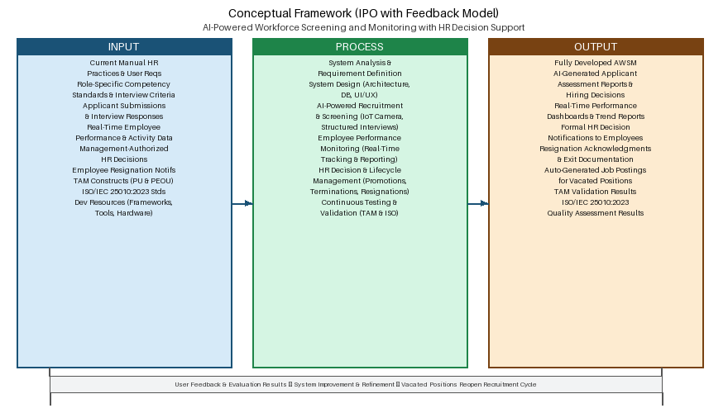
Figure 1.1 IPOF Model

Hypothesis of the Study
H₀₁: The AWSM does not have a significant effect on the Perceived Usefulness (PU) and Perceived Ease of Use (PEOU) of HR personnel, department managers, and employees.
H₁₁: The AWSM has a significant effect on the Perceived Usefulness (PU) and Perceived Ease of Use (PEOU) of HR personnel, department managers, and employees.
H₀₂: There is no significant relationship between PEOU and PU in influencing users' acceptance of the AWSM.
H₁₂: There is a significant relationship between PEOU and PU in influencing users' acceptance of the AWSM.
H₀₃: The AWSM does not achieve satisfactory ratings for functional suitability, performance efficiency, and usability as evaluated against the ISO/IEC 25010:2023 software quality standard.
H₁₃: The AWSM achieves satisfactory ratings for functional suitability, performance efficiency, and usability as evaluated against the ISO/IEC 25010:2023 software quality standard.
H₀₄: The AWSM does not produce measurable improvements over manual HR processes in terms of recruitment processing speed, consistency of HR decision communication, and reduction of administrative delays in workforce transitions.
H₁₄: The AWSM produces measurable improvements over manual HR processes in terms of recruitment processing speed, consistency of HR decision communication, and reduction of administrative delays in workforce transitions.

CHAPTER 2

SYSTEM DEVELOPMENT

System Development Methodology
This study utilizes the Agile Software Development Methodology as the SDLC model in developing the AI-Powered Workforce Screening and Monitoring with HR Decision Support. Agile is an iterative and incremental approach that promotes flexibility, continuous stakeholder collaboration, and rapid delivery of functional system components through short development cycles known as sprints (Kent Beck et al., 2001).
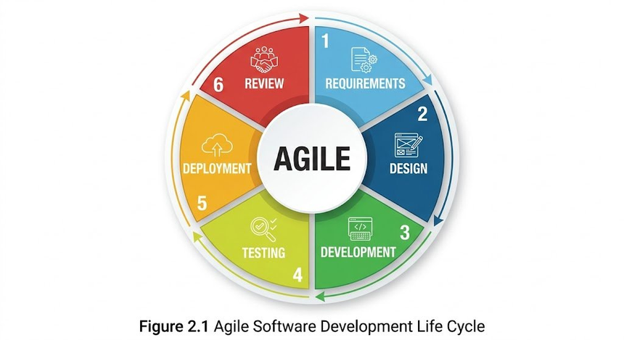
Figure 2.1 Agile Software Development Life Cycle (SDLC)

Requirements Analysis
This section presents the requirement specifications and analysis for the proposed AI-Powered Workforce Screening and Monitoring with HR Decision Support. It defines and organizes the system requirements based on data gathered from HR personnel, department managers, and employees of Sunnies Studios through structured interviews, observations, and document analysis of existing HR workflows.
The functional requirements describe the specific features and operations that the system must perform. These include: role-based access control for HR personnel, department managers, and employees; automated job vacancy posting to the organization's website and Facebook upon position opening; a pre-interview document submission portal requiring applicants to upload their resume or CV, government-issued identification, relevant certificates and credentials, and employment records or TOR; AI-powered resume and document assessment prior to the interview; IoT-integrated camera functionality during the online interview including pre-interview environment check, facial expression and gesture analysis, applicant identity verification, and real-time cheating behavior detection; AI-conducted structured online interviews with role-specific and position-varied questions; an integrated assessment module for competency-based testing; real-time monitoring and reporting of employee performance indicators; supervisor-to-subordinate performance evaluation workflows; processing of management-authorized promotions and terminations with formal email notification generation; receipt and processing of employee resignation submissions through the AI interface; automatic creation of new job postings for vacated positions to restart the hiring cycle; automated email notifications to stakeholders at every stage of every transaction; and capture and maintenance of the complete employment history of every individual from application to end of contract.

Existing System
The existing HR management process at Sunnies Studios is primarily manual and semi-computerized, relying heavily on paper-based records, spreadsheets, and individual scheduling for recruitment, performance review, and lifecycle management. Recruitment is handled through unstructured interviews conducted by individual HR staff members, with no standardized evaluation criteria applied consistently across candidates. Given that Sunnies Studios operates over 127 store locations and employs approximately 500 to 607 personnel across retail, corporate, and lifestyle brand divisions — including Sunnies Specs, Sunnies Face, and Sunnies Café — the volume and diversity of its hiring needs make inconsistent, unstructured recruitment a significant operational risk. Performance monitoring is conducted through periodic written reviews that occur only at scheduled intervals, providing no real-time visibility into workforce productivity. Management decisions such as promotions and terminations are communicated informally, with no centralized system for processing, documenting, or tracking these decisions.
When an employee resigns, the organization must manually identify the vacancy, prepare a new job posting, and initiate a separate recruitment process — entirely disconnected from the exit process and prone to delays. There is no system for capturing the complete employment history of individuals across their tenure, making it difficult to maintain auditable records from application through offboarding. The absence of a unified system means HR teams must coordinate across multiple tools, increasing the risk of data inconsistency, missed follow-through, and avoidable workforce pipeline gaps.
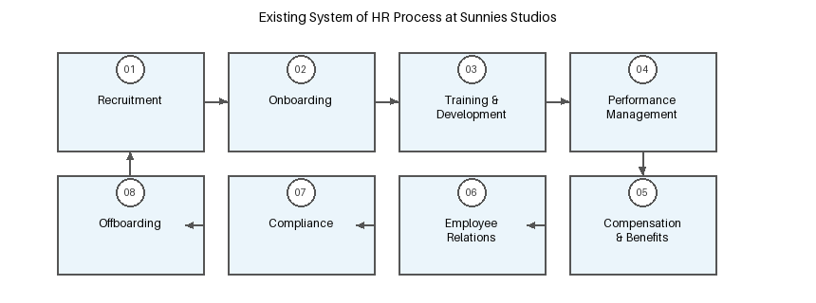
Figure 2.2 Existing System of HR Process at Sunnies Studios — The current HR lifecycle relies on manual forms, spreadsheets, and informal communication, leading to inefficiencies and delays.

Proposed System
The proposed system is the AI-Powered Workforce Screening and Monitoring with HR Decision Support (AWSM), a web-based application that centralizes and automates the full employment lifecycle under a single AI agent, developed specifically for deployment at Sunnies Studios. The system provides HR personnel, department managers, and employees with role-based access to a unified platform that handles recruitment, performance monitoring, and workforce transitions in an integrated and continuously operating manner.
A defining feature of the AWSM is the AI agent, which is trained on Sunnies Studios' role requirements, competency benchmarks, and performance records before deployment. When a position becomes vacant, the system posts it to the website and Facebook. Applicants submit required documents — resume/CV, government-issued ID, certificates, and employment records/TOR — which the AI assesses prior to the interview. Before the interview begins, the IoT camera checks the applicant's environment for compliance. During the role-specific interview — with questions that vary by position — the camera analyzes facial expressions and gestures, verifies identity, and monitors for cheating behaviors. The AI evaluates all inputs and produces a formal assessment summary and hiring recommendation for HR review. Once employees are onboarded, the AI monitors performance in real time, supports supervisor-to-subordinate evaluations, and provides dashboards to managers and HR. When management authorizes a promotion or termination, the AI processes the decision and sends formal email notifications. When an employee resigns, the system processes the exit and automatically creates a new job posting. Throughout all transactions, automated email notifications keep all relevant parties informed. The system captures the complete employment history of every individual from application to end of contract, ensuring full lifecycle auditability.

Figure 2.3 Proposed System Overview

System Design

Logical Specifications — Data Flow Diagram
The Data Flow Diagram (DFD) provides information about the outputs and inputs of each entity and the process itself. The Level 0 (Context) diagram shows the five external entities that interact with the AWSM: HR Personnel, Upper Management, Department Managers, Employees, and Applicants.
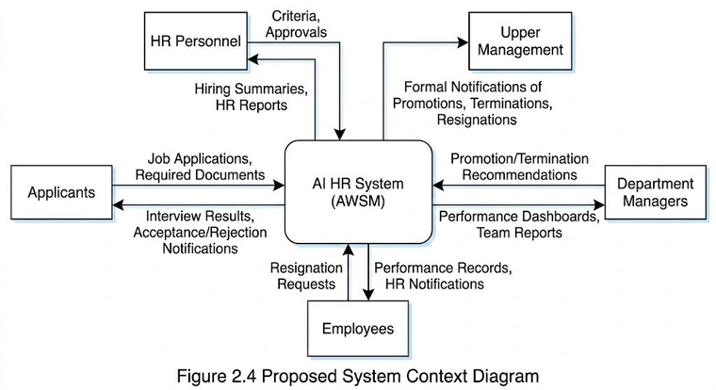
Figure 2.4 Proposed System Context Diagram (Level 0 DFD)

Physical Specifications — Visual Table of Contents
The Visual Table of Contents (VTOC) represents the hierarchical structure that outlines the functions, contents, and interconnections within the AWSM. At the top lies the system name, with the primary modules in the subsequent tier. New modules added based on panelist feedback — including the Document Upload Portal, Assessment Module, IoT Camera Module, and History Tracker — are highlighted in the structure below.
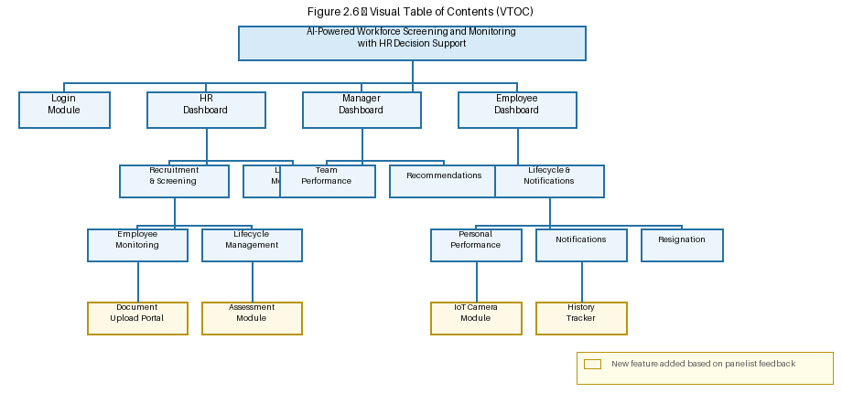
Figure 2.6 Visual Table of Contents

Respondents and Setting of the Study
This study will be conducted within Sunnies Studios (Sunnies Inc.), a Philippine-based lifestyle and eyewear brand headquartered in Mandaluyong, Metro Manila. Founded in 2013, Sunnies Studios operates over 127 store locations across the Philippines and Vietnam, with a workforce of approximately 500 to 607 employees across Sunnies Specs, Sunnies Face, and Sunnies Café. This organization was selected because its existing HR processes reflect precisely the conditions the AWSM is designed to address.
The respondents will consist of HR personnel, department managers, and employees of Sunnies Studios who will directly use or interact with the system. The study will utilize non-probability sampling, specifically purposive sampling (Creswell, 2014).

Table 3
Respondent Distribution According to Type of End-User
END-USERS | NUMBER OF RESPONDENTS
HR Personnel | 15
Department Managers | 10
Employees | 20
IT / Software Quality Evaluators | 5
TOTAL | 50

Table 2
Hardware, Software, and Technology Requirements
ITEM | MINIMUM REQUIREMENTS
Processor | Intel Core i5 or equivalent, dual core @ 2.4 GHz or better
Memory | 8 GB of RAM
Hard Disk Space | 320 GB hard drive
Operating System | Microsoft Windows 10 or higher / macOS 11 or higher
Internet Connection | Stable broadband connection (minimum 10 Mbps)
Front-End Framework | React.js
Back-End Framework | Node.js with Express.js
Database | MySQL
AI Engine | Large Language Model API
IoT Camera (Applicant Side) | Web camera with minimum 720p resolution; browser-based WebRTC (no hardware install required)
AI Vision Module | Computer vision API for environment check, facial expression analysis, identity verification, and behavioral monitoring
Social Media API | Facebook Graph API for automated job vacancy posting
Document Upload Portal | Secure file upload system supporting PDF, JPG, and PNG formats with server-side validation
Assessment Module | Role-specific competency assessment engine integrated within the screening pipeline
Notification System | Automated email notification engine triggered at each transaction stage (application, interview, hiring, onboarding, evaluation, decision, resignation)
History Tracker | Longitudinal employment record system capturing full lifecycle from application to end of contract
Version Control | Git / GitHub
Development Environment | Visual Studio Code with ESLint
Cloud Hosting | Cloud infrastructure platform (e.g., AWS, DigitalOcean)

